Dis-Asia-Pakistan-Mohenjodaro-Seal-2017-6

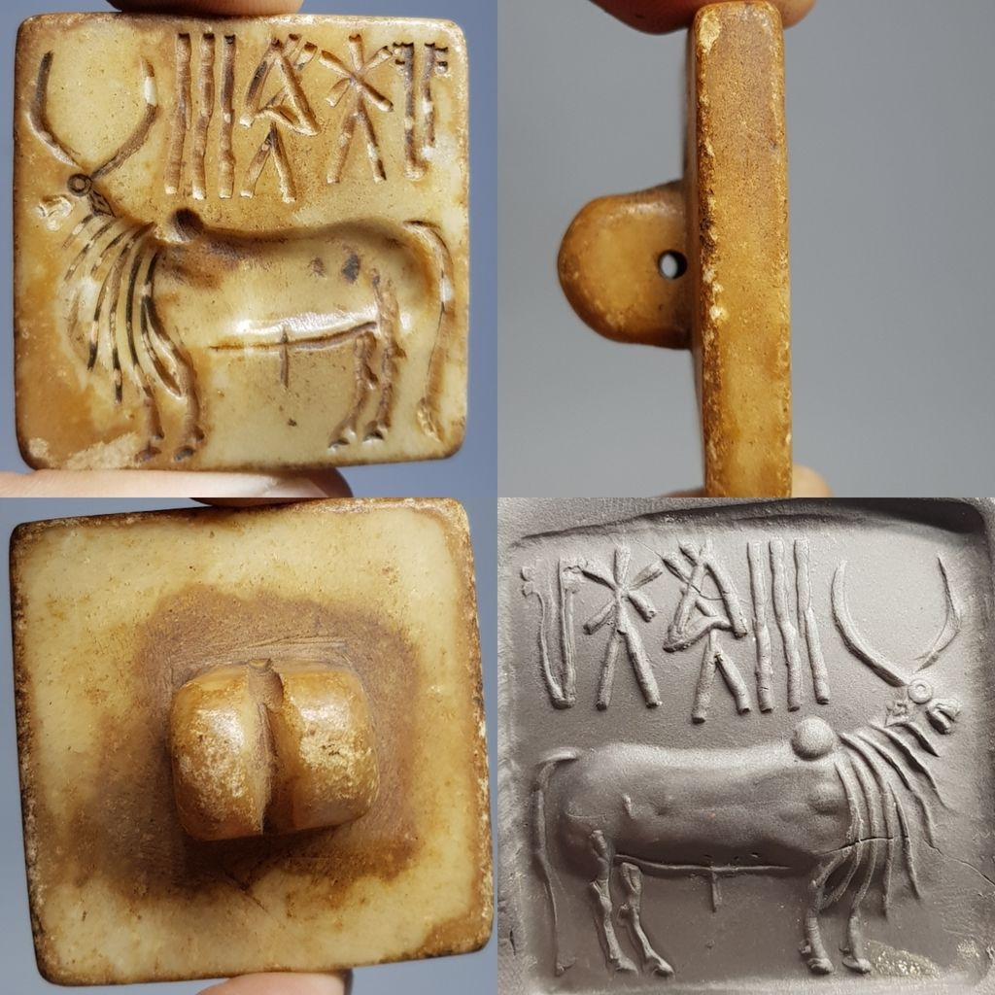

**Case no.: 3**

**Accession Number:**

**Formal Label: Mohenjo-Daro Seal**

**Display Description:**  **Mohenjo-Daro,** an archaeological site in the province of [Sindh](https://en.wikipedia.org/wiki/Sindh), [Pakistan](https://en.wikipedia.org/wiki/Pakistan) ca 2500 BCE was one of the largest cities with remarkably sophisticated civil engineering and urban planning.[[12]](https://en.wikipedia.org/wiki/Mohenjo-daro#cite_note-12) of the ancient [Indus Valley Civilization](https://en.wikipedia.org/wiki/Indus_Valley_Civilization), also known as the [Harappan](https://en.wikipedia.org/wiki/Harappa" \o "Harappa) Civilization.[[11]](https://en.wikipedia.org/wiki/Mohenjo-daro#cite_note-11) It developed around 3,000 BCE from the prehistoric Indus culture and extended west to the [Persian](https://en.wikipedia.org/wiki/Iran) border, south to [Gujarat](https://en.wikipedia.org/wiki/Gujarat) in India and north to [Bactria](https://en.wikipedia.org/wiki/Bactria). Its major urban centers were located at Harappa, Mohenjo-Daro, [Lothal](https://en.wikipedia.org/wiki/Lothal), [Kalibangan](https://en.wikipedia.org/wiki/Kalibangan" \o "Kalibangan), [Dholavira](https://en.wikipedia.org/wiki/Dholavira" \o "Dholavira) and [Rakhigarhi](https://en.wikipedia.org/wiki/Rakhigarhi" \o "Rakhigarhi). When the Indus valley civilization went into sudden decline around 1900 BCE, Mohenjo-daro was abandoned.[[10]](https://en.wikipedia.org/wiki/Mohenjo-daro#cite_note-Ancientindia.co.uk-10)[[13]](https://en.wikipedia.org/wiki/Mohenjo-daro#cite_note-KenoyerArticle-13)

One of the most enigmatic aspects of [Indus Valley Civilization](https://en.wikipedia.org/wiki/Indus_Valley_Civilization) is the **Indus script** which is known from symbols produced on stone seals beginning during the pre-Indus period at the [Kot Diji](https://en.wikipedia.org/wiki/Kot_Diji) site ca 3300 BCE. Since the seals containing these symbols are very short it is not known whether their symbols constitute a script of a language or a [writing system](https://en.wikipedia.org/wiki/Writing_system).[[4]](https://en.wikipedia.org/wiki/Indus_script#cite_note-Locklear-4) Consequently,[[5]](https://en.wikipedia.org/wiki/Indus_script" \l "cite_note-5) 'the script' has not yet been deciphered. There is no known [bilingual inscription](https://en.wikipedia.org/wiki/Bilingual_inscription) to help decipher the script. While the script is relatively stable over time, the syntax of the signs has been shown to vary with the location in which they were produced.[[4]](https://en.wikipedia.org/wiki/Indus_script#cite_note-Locklear-4)

Harappan symbols were first published in 1875, in a drawing by [Alexander Cunningham](https://en.wikipedia.org/wiki/Alexander_Cunningham).[[6]](https://en.wikipedia.org/wiki/Indus_script#cite_note-6) Since then, over 4,000 inscribed objects have been discovered, some as far afield as [Mesopotamia](https://en.wikipedia.org/wiki/Mesopotamia). In the early 1970s, [Iravatham Mahadevan](https://en.wikipedia.org/wiki/Iravatham_Mahadevan" \o "Iravatham Mahadevan) published a [corpus](https://en.wikipedia.org/wiki/Text_corpus) and [concordance](https://en.wikipedia.org/wiki/Concordance_(publishing)) of Indus inscriptions listing 3,700 seals and 417 distinct signs in specific patterns. He also found that the average inscription contained five symbols, and the longest inscription contained only 14 symbols in a single line.[[7]](https://en.wikipedia.org/wiki/Indus_script#cite_note-7) He also established the direction of writing as right to left.[[8]](https://en.wikipedia.org/wiki/Indus_script#cite_note-natureindia2009-8)

**LC Classification:**  [**PK119**](http://laurel.lso.missouri.edu/search~S1?/cPK119+.N49+1984+12/cpk++119+n49+1984+12/-3,-1,,E/browse)

**Date or Time Horizon:**

**Geographical Area:**

**Map, GPS coordinates:** [7°19′45″N 68°08′20″E](https://tools.wmflabs.org/geohack/geohack.php?pagename=Mohenjo-daro&params=27_19_45_N_68_08_20_E_type:landmark)

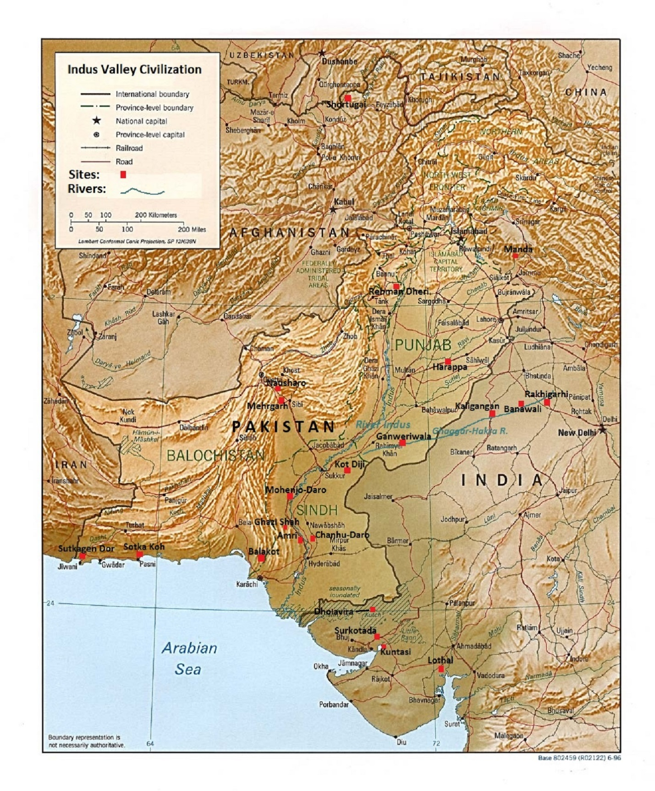

**Cultural Affiliation:** Indus Valley Civilization.

**Media: Steatite**

**Dimensions:** 42 cm.

**Weight:**

**Condition: Original**

**Provenance:** Indus Valley Civilization.

**Discussion:** Some scholars, such as G.R. Hunter,[[9]](https://en.wikipedia.org/wiki/Indus_script#cite_note-Hunter_1934-9) [S. R. Rao](https://en.wikipedia.org/wiki/S._R._Rao), John Newberry,[[10]](https://en.wikipedia.org/wiki/Indus_script#cite_note-10) [Krishna Rao](https://en.wikipedia.org/wiki/Krishna_Rao_(archeologist)),[[11]](https://en.wikipedia.org/wiki/Indus_script#cite_note-11) and [Subhash Kak](https://en.wikipedia.org/wiki/Subhash_Kak" \o "Subhash Kak)[[12]](https://en.wikipedia.org/wiki/Indus_script#cite_note-12) have argued that the [Brāhmī script](https://en.wikipedia.org/wiki/Br%C4%81hm%C4%AB_script" \o "Brāhmī script) has some connection with the Indus system, while others such as [Iravatham Mahadevan](https://en.wikipedia.org/wiki/Iravatham_Mahadevan" \o "Iravatham Mahadevan), [Kamil Zvelebil](https://en.wikipedia.org/wiki/Kamil_Zvelebil" \o "Kamil Zvelebil) and [Asko Parpola](https://en.wikipedia.org/wiki/Asko_Parpola" \o "Asko Parpola) have argued that the script had a relation to a [Dravidian language](https://en.wikipedia.org/wiki/Dravidian_languages).[[13]](https://en.wikipedia.org/wiki/Indus_script#cite_note-13)[[14]](https://en.wikipedia.org/wiki/Indus_script#cite_note-14) [F. Raymond Allchin](https://en.wikipedia.org/wiki/F._Raymond_Allchin) has somewhat cautiously supported the possibility,[[15]](https://en.wikipedia.org/wiki/Indus_script#cite_note-15)[[16]](https://en.wikipedia.org/wiki/Indus_script#cite_note-16) that even many supporters of the theory that Brāhmī probably derives from [Aramaic](https://en.wikipedia.org/wiki/Aramaic_alphabet) influence consider: that the Brahmi language can have some Indus script influence.[[17]](https://en.wikipedia.org/wiki/Indus_script#cite_note-Salomon_1995-17) Another possibility for continuity of the Indus tradition is in the [megalithic culture graffiti symbols](https://en.wikipedia.org/wiki/Megalithic_Graffiti_Symbols) of southern and central India (and Sri Lanka), which probably do not constitute a linguistic script but may have some overlap with the Indus symbol inventory.[[18]](https://en.wikipedia.org/wiki/Indus_script#cite_note-18)[[19]](https://en.wikipedia.org/wiki/Indus_script#cite_note-19)

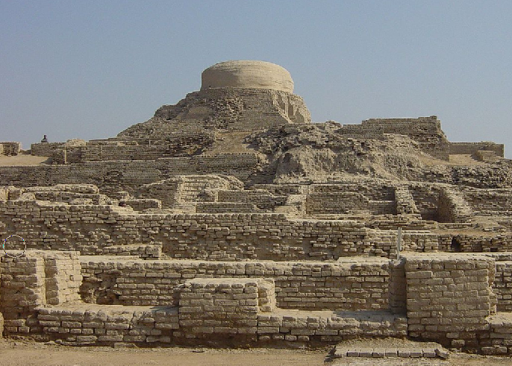

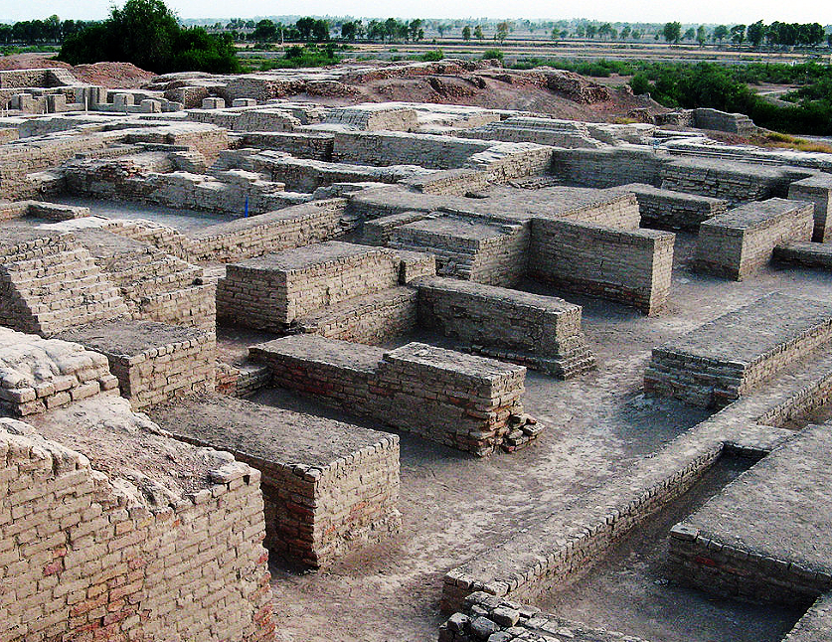

**References:**